RSA Design Document

**Overview:**

In RSA, a combination of public key and private key is used to encrypt and decrypt information which is to be transferred between sender and receiver. When a sender sends sensitive information to receiver, this information is encrypted with receiver’s public key and then transmitted further. Once it reaches to the receiver, he/she can decrypt it using their own private keys and access the information.

**Class Diagram:**

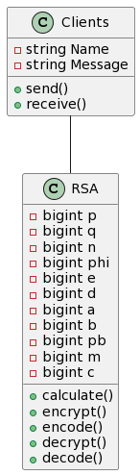

**Sequence Diagram:**

